We use version control system to save, keep track of our teams progress and preventing from losing the changes

Version control system we will using for this project is GIThub

There are multiple flows we can follow to merge our changes into production but the one we choose is GIT flow

We planned to do release after each sprint and we needed multiple branches like development and QA to merger changes and test for each sprint which is not the case with github flow where we use only two branches to trach out changes that’s why we choose gitflow

(Hyett, 2022) &  (Phillips et al., 2011)

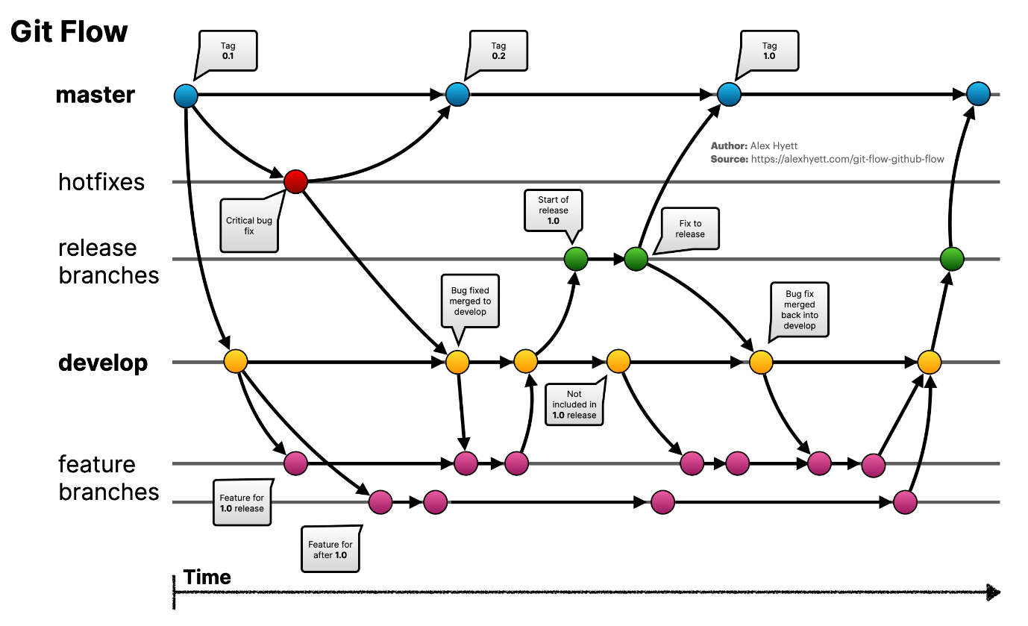

(Hyett, 2022)

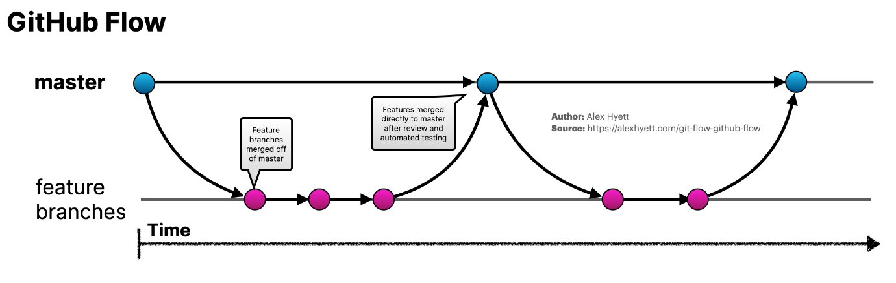

(Hyett, 2022)

We use gitflow with some tweeks

Feature Branches will be used by developers to push their code every story will have their own feature branch.

Once the developer is happy with feature branch he can raise the pull request to team members in order to merge into develop branch

Our team set the criteria that we need to have minimum of 2 approvals in order to merge

Once all the stories are closed for that sprint all the changes will be moved to QA where it will be deployed and tested

We are using regressing testing so far but planned to do automation.

If branch has been signed off to merge then it will be merged into production branch where I will be deployed and quick testing will be done.

And after the sprint over with production code deployed it will be moved to main branch for backup just in case if anything goes wrong.

This process is and will be followed thoughout the project.

Phillips, S., Sillito, J., & Walker, R. (2011). Branching and merging. *Proceedings of the 4th International Workshop on Cooperative and Human Aspects of Software Engineering*. <https://doi.org/10.1145/1984642.1984645>

Hyett, A. (2022, November 10). *Git Flow vs GitHub Flow*. Alex Hyett. https://www.alexhyett.com/git-flow-github-flow/

‌